A793-A800-US-NY-MA-Algonquian-Hoes-7000 BP

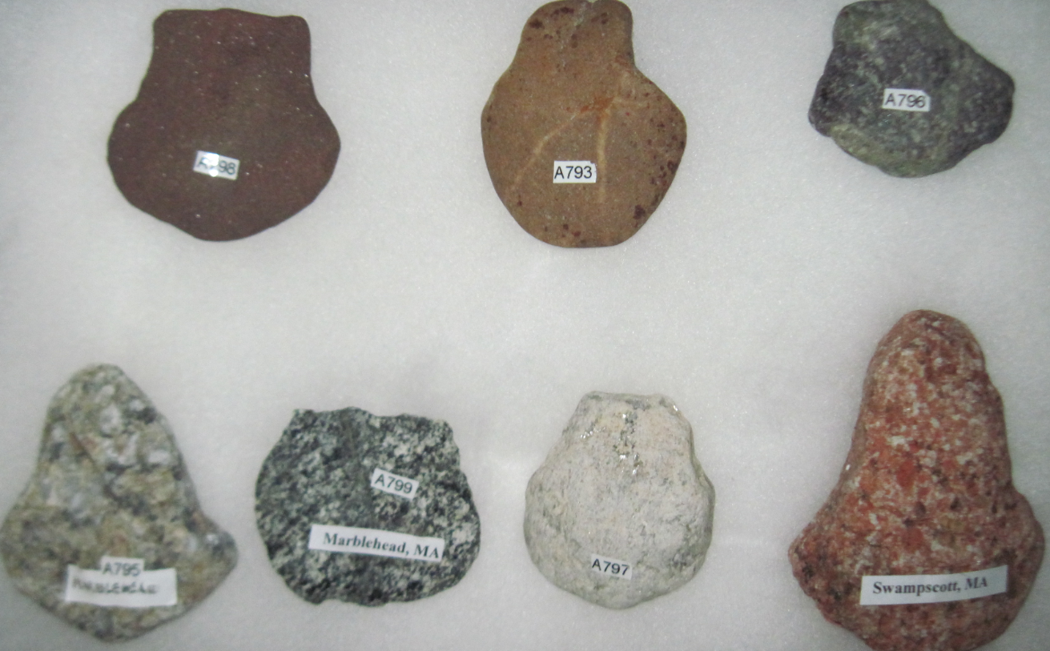

Case No.: 12

**Accession Nos.A793-800**

**Formal Label:** US-NY-MA-Algonquian-Hoes-7000 BP

**Display Description:**

Rare Archaic Clam Digging Hoes, 7000 BP, from Glen Cove Beach, Long Island, and Devereux Beach, Marblehead. The three hoes at the top are from Glen Cove, Long Island, where the historic tribes are the Matinecock, Nesaquake, Setalcott, and Corchaug. The four hoes on the bottom are from Marblehead and Swampscott, MA where the historic tribe is the Naumkeag. These seven hoes document the persistence of the use of a lithic design by Eastern Algonquian shell fisher bands. The seven hoes have very similar designs: the blade is about two inches broad with a narrower hafting section so it could be lashed on a right-angled limb of a sapling. Such similar designs suggests they were made by a common Archaic culture with a similar maritime lifeway. From linguistics we know that the region between New Jersey and Maine was inhabited by peoples who spoke Algonquian languages, and so we may postulate that these tools were made by ancestors of Algonquians. No other examples of this tool have been found in any of the major archaeological collections.

**LC Classification: E99.A35**

**Date or Time Horizon: 7000 BP**

**Geographical Area: Marblehead, Massachusetts to the north shore of Long Island, NY**

**Map:**

**GPS coordinates:**

**Cultural Affiliation: Algonquians**

**Media: granite, quartz, mudstone, jasper**

**Dimensions: H 3-4 in**

**Weight:**

**Condition: original**

**Provenance: Marblehead, Massachusetts to the north shore of Long Island, NY**

**Discussion:**

**References:**